**[NLMFFC-1550-0001]**

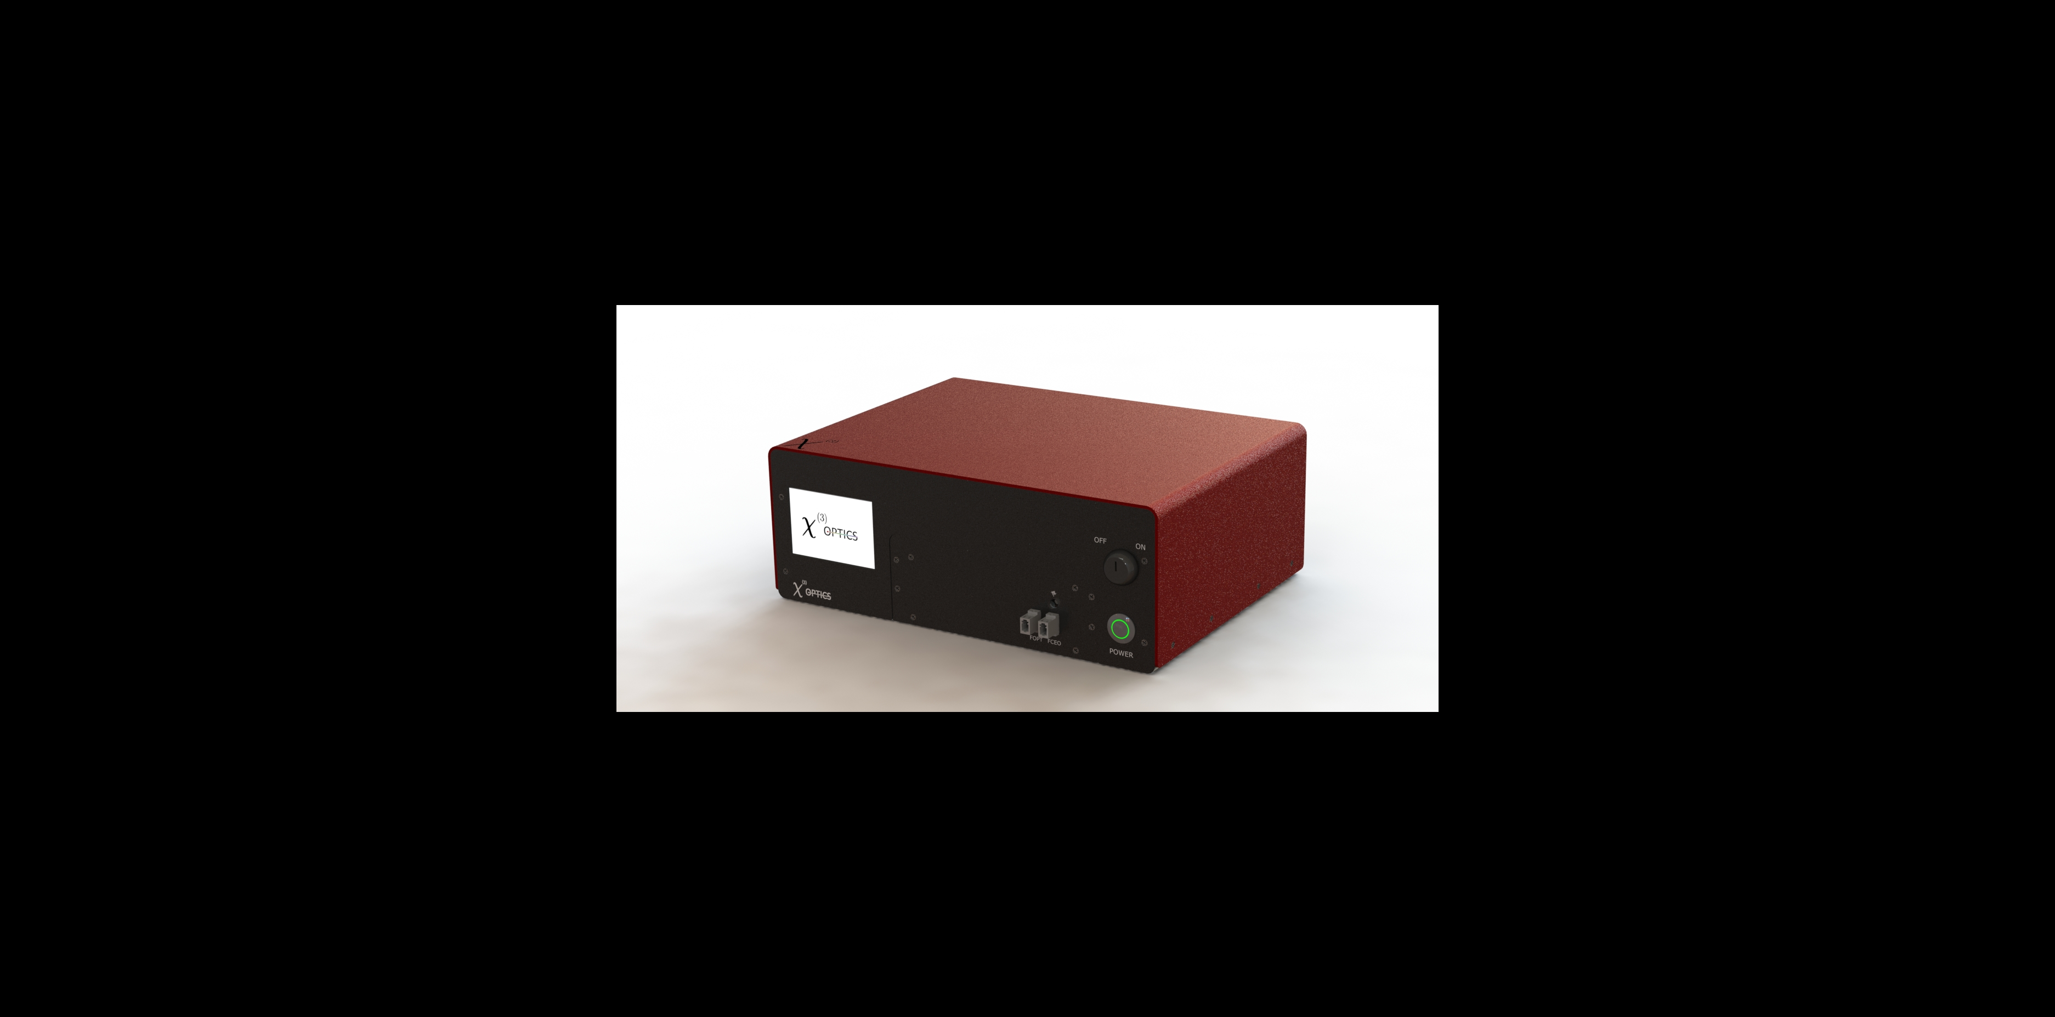

Table of Contents

1. Absolute Maximum Ratings 3

2. General Specification 3

3. Connection Diagram 5

# Absolute Maximum Ratings

|  |  |  |  |  |
| --- | --- | --- | --- | --- |
| Parameter | Min | Typ | Max | Units |
| Input Voltage AC | 100 | 110 | 240 | Volts |
| SLOW PZT* | -20 | 0 | 150 | Volts |
| FAST PZT* | -20 | 0 | 150 | Volts |
| SERVO INPUT | -1 | 0 | 1 | Volts |
| EXTERNAL INTERLOCK | 0 | 0 | 3.3 | Volts |
| STORAGE TEMPERATURE | -10 | 23 | 70 | Celsius |
| OPERATING TEMPERATURE | 15 | 23 | 26 | Celsius |

# General Specification

`

|  |  |  |  |  |
| --- | --- | --- | --- | --- |
| Parameter | Min | Typ | Max | Units |
| Repetition Rate | 80 | 100 | 200 | MHz |
| Servo Input Bandwidth | - | 150 | 300 | KHz |
| Servo Input Tuning | - | 20 | - | mA/V |
| SLOW PZT Bandwidth1 | - | - | 10 | KHz |
| SLOW PZT Tuning | - | 7 | - | Hz/V |
| FAST PZT Bandwidth1 | - | 80 | 130 | KHz |
| FAST PZT Tuning | - | 0.66 | - | Hz/V |
| F_Optical Output Power | - | 2 | 5 | mW |
| F_Optical Bandwidth2 | 100 | 150 | 200 | nm |
| F_CEO Output Power | - | 1 | 2 | mW |
| F_CEO Output Spectrum | 15 | 23 | 26 | Celsius |
| F_OPT/F_CEO Crosstalk3 |  | 0.8 |  | MHz/V |
| F_CEO S/N Ratio | 30 | 40 | 60 | dB |
|  |  |  |  |  |
|  |  |  |  |  |

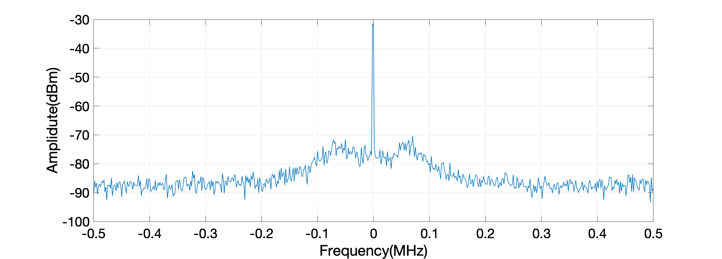

SNR:~50dB

RBW:300Hz

Figure 1: Typical Phase Locked FCEO Signal

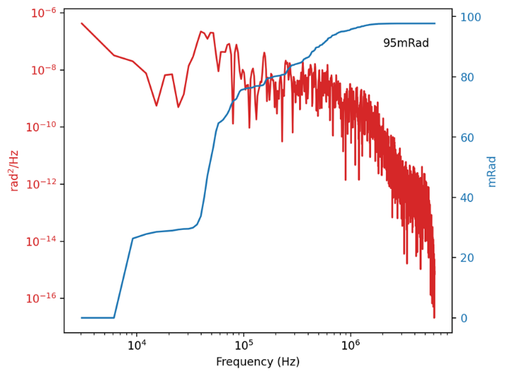

Figure . Integrated phase noise using open source locking electronics.

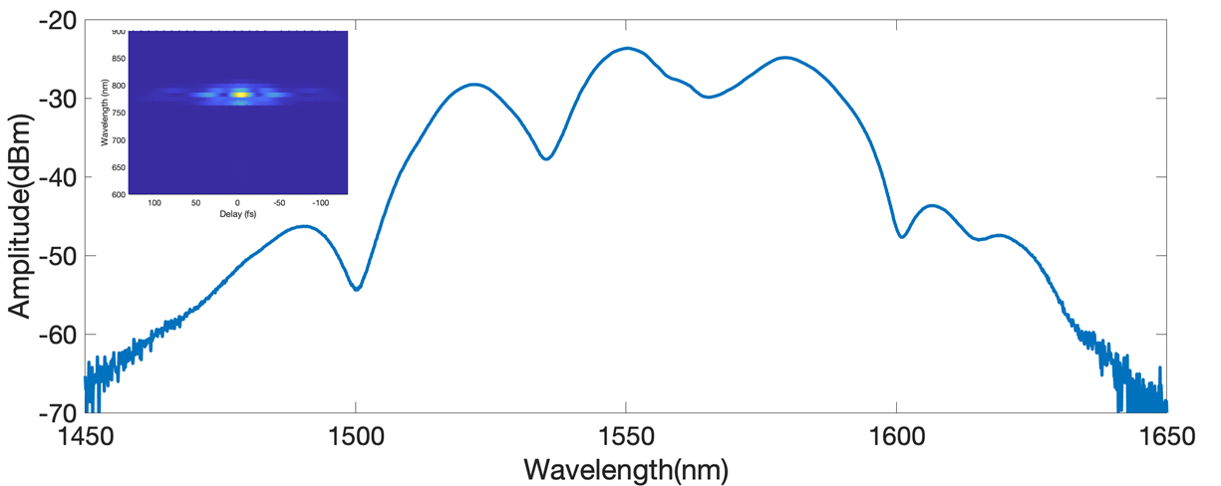

Figure 3: Typical Optical Output Spectrum

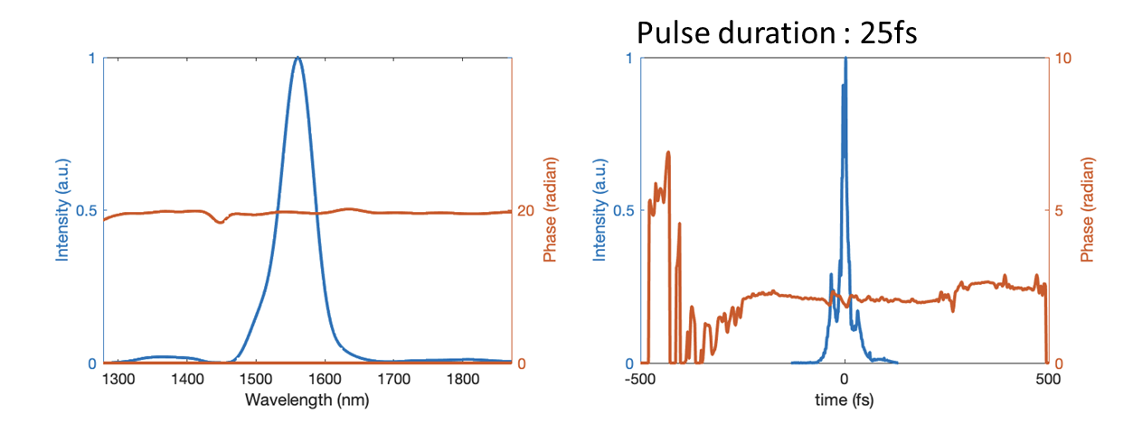

Figure . Typical Pulse Width

Figure 5: Repetition Rate Stability

# Connection Diagram

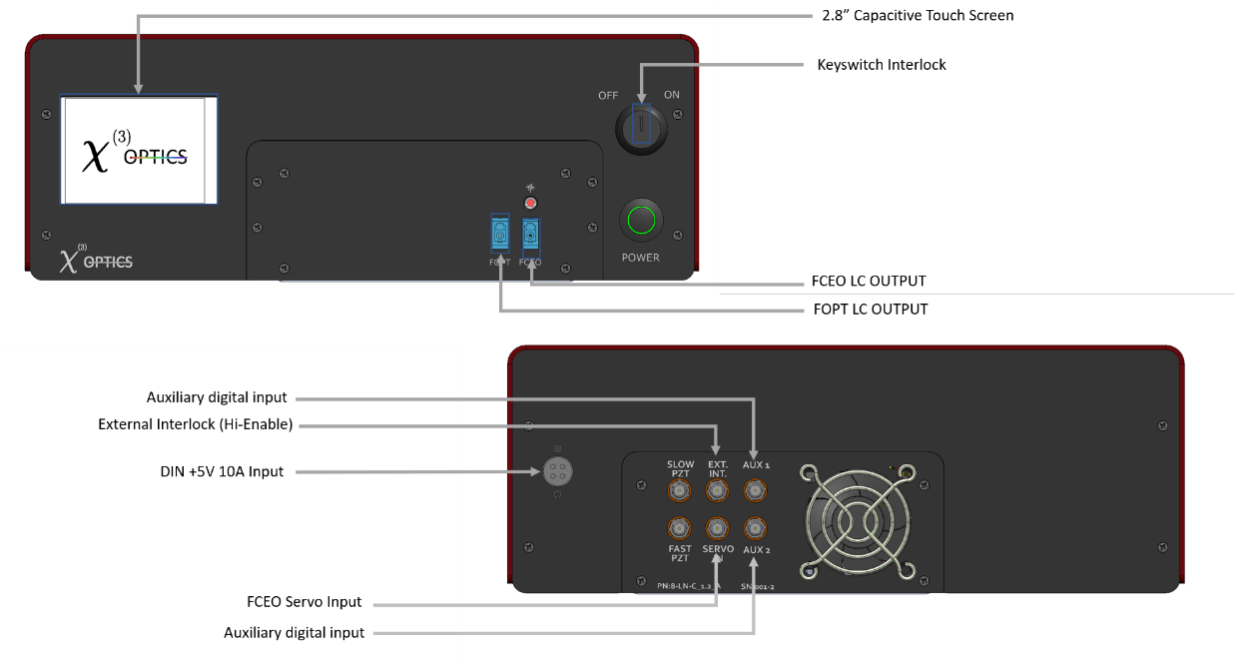

Figure . Comb Front Panel(Top) and Rear Panel (Bottom) Connections.

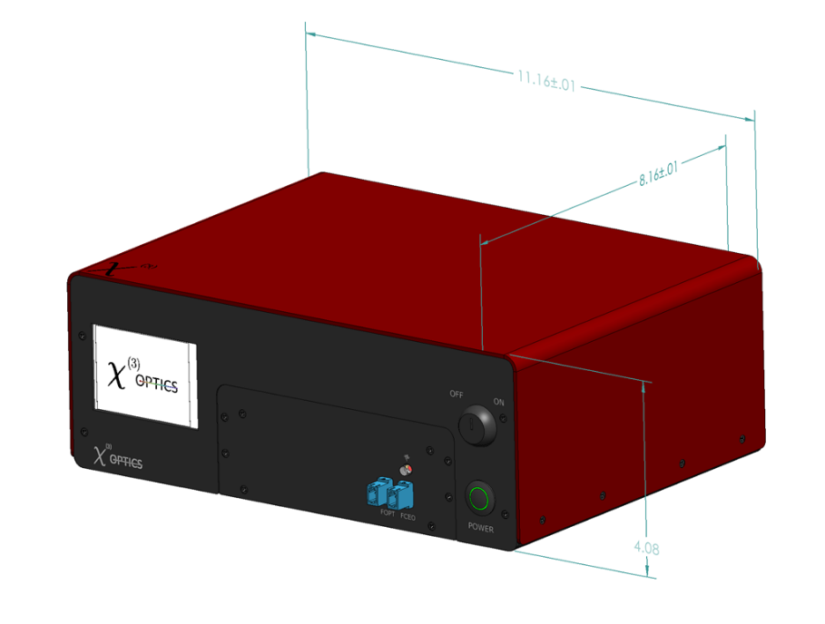

Figure . Dimensions of Desktop Comb.